DATA ANALYSIS INTERNSHIP – DAY 23 REPORT
Organization: Top Tech Developers
Topic Covered: Employee Relationship Building and Dashboard Creation in Power BI

Introduction
Microsoft Power BI is a powerful business intelligence and data visualization tool used to analyze, model, and visualize organizational data. One of the key features of Power BI is relationship building, which allows multiple datasets to be connected for effective reporting and dashboard creation.
On Day 23 of the internship, employee datasets were connected using different relationship types in Model View, and an interactive employee dashboard was developed to analyze employee, department, project, attendance, and salary information.

Objective
The objective of this session was:
- To build relationships between employee datasets
- To understand different relationship types in Power BI
- To create an interactive employee analysis dashboard
- To visualize employee performance and organizational data effectively

1. Datasets Used
Two employee-related datasets were used for analysis and dashboard creation.
Employee_Table
This dataset contained basic employee and project information.
Columns Included
- Employee_ID
- Employee_Name
- Department_ID
- Department_Name
- Project_ID
- Project_Name
- Salary

Employee_Details
This dataset contained additional employee information.
Columns Included
- Employee_ID
- Email
- Phone
- Attendance
- Experience_Years
- Department_ID
- Project_ID

2. Relationship Building in Power BI
Relationships were created using the Model View in Microsoft Power BI.
The datasets were connected through common fields to enable integrated analysis and reporting.

1. One-to-Many Relationship
Connection
Employee_Table.Employee_ID
↓
Employee_Details.Employee_ID
Explanation
- One employee record in Employee_Table can be associated with multiple detail records in Employee_Details.
- This relationship helps combine employee information with attendance and experience details.
Observation
- Employee data was linked successfully across both tables.
- Relationship improved report accuracy and filtering.

2. Many-to-One Relationship
Connection
Employee_Details.Department_ID
↓
Employee_Table.Department_ID
Explanation
- Multiple employees belong to a single department.
- Department information can be used across several employee records.
Observation
- Department-wise employee analysis became possible.
- Data aggregation improved reporting efficiency.

3. Many-to-Many Relationship
Connection
Employee_Table.Project_ID
↔
Employee_Details.Project_ID
Explanation
- Multiple employees can work on multiple projects.
- A project can involve several employees simultaneously.
Observation
- Project allocation analysis became easier.
- Employee-project relationships were visualized effectively.

3. Dashboard Creation
After building relationships successfully, an employee dashboard was created using different visualizations.
The dashboard provided insights into:
- Employee salary distribution
- Department performance
- Project allocation
- Attendance records
- Employee experience levels

4. Visualizations Used
1. Bar Chart
Purpose
Count of Project_ID by Project_Name
Projects Displayed
- AI System
- Web App
- Mobile App
- Payroll System
Observation
- Project participation was compared visually.
- Active projects were identified easily.

2. KPI Cards
KPI cards were used to display important employee metrics.
KPI | Value
Sum of Salary | 525K
Sum of Experience Years | 34
Purpose
- Provides quick business insights
- Highlights important employee statistics
Observation
- Salary and experience information became instantly visible.
- Dashboard readability improved significantly.
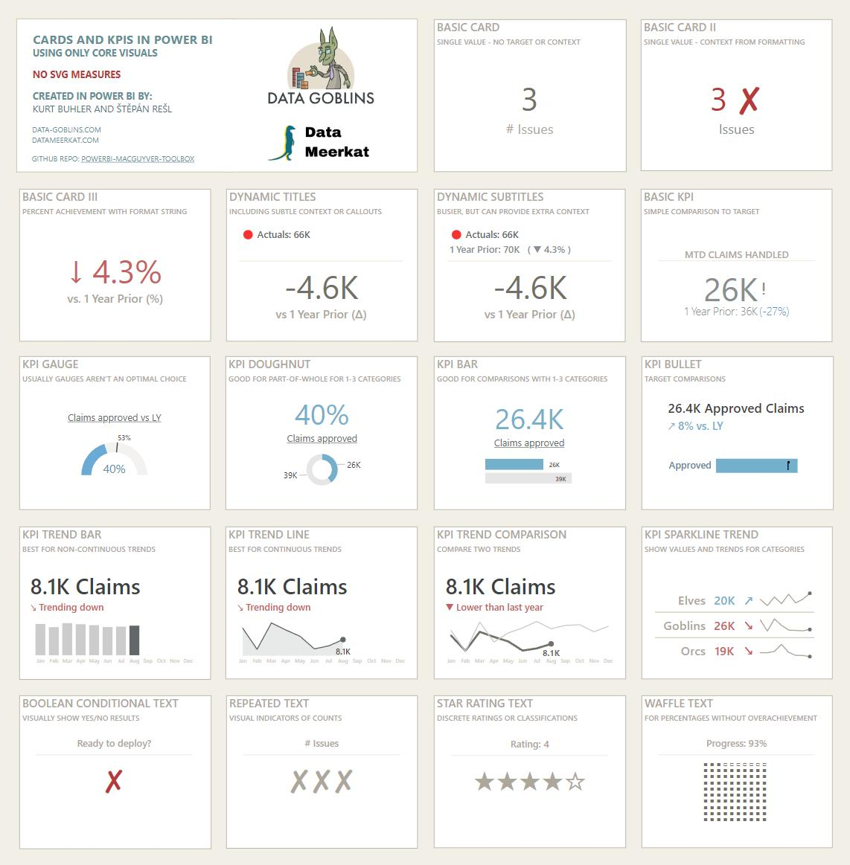
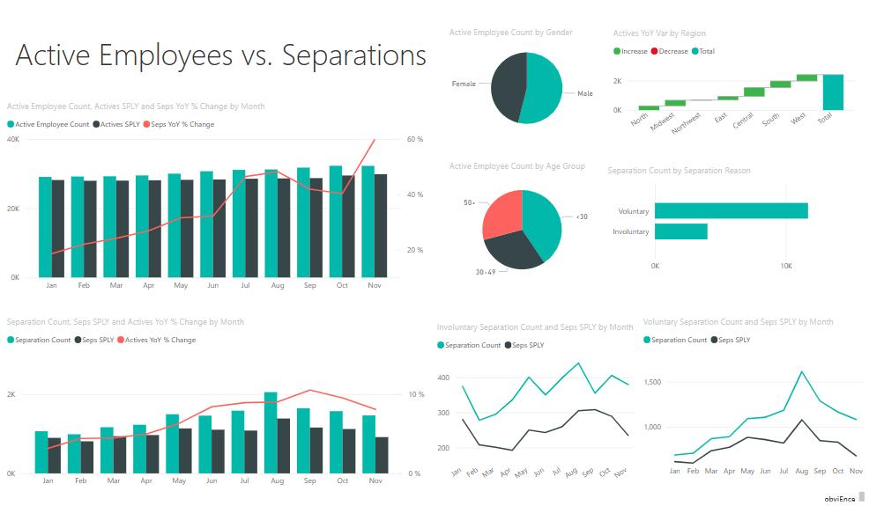
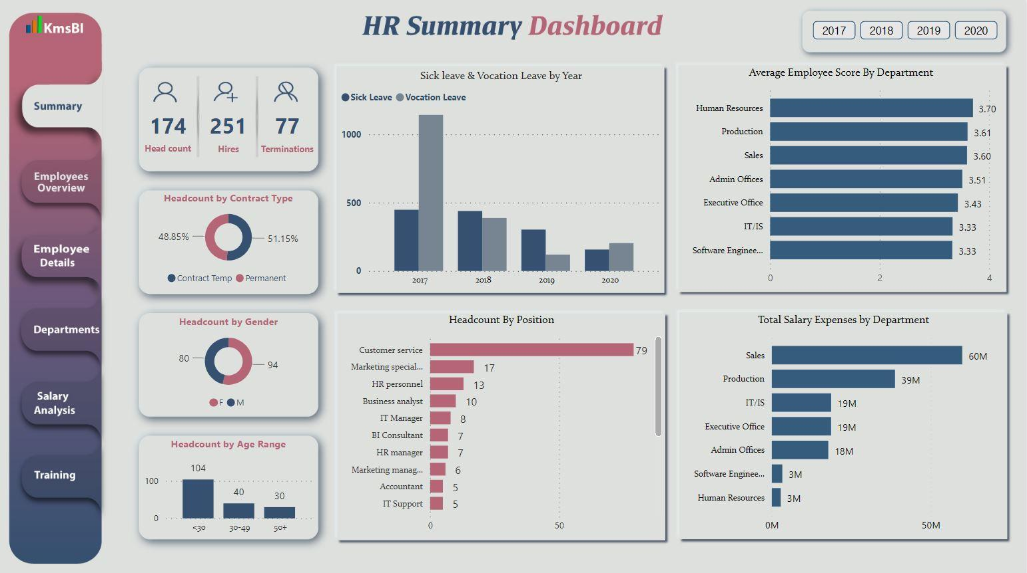

3. Area Chart
Purpose
Count of Project_Name by Department_ID
Departments Included
- D1
- D2
- D3
Observation
- Project allocation across departments was visualized.
- Department-wise project participation became easier to analyze.

4. Pie Chart
Purpose
Sum of Salary by Department_Name
Departments Displayed
- HR
- IT
- Finance
Observation
- Salary contribution by department was represented clearly.
- Department comparison became easier through percentage visualization.

5. Funnel Chart
Purpose
Count of Attendance by Department_ID
Departments Included
- D1
- D2
- D3
Observation
- Attendance distribution was compared across departments.
- Funnel visualization highlighted department participation levels.
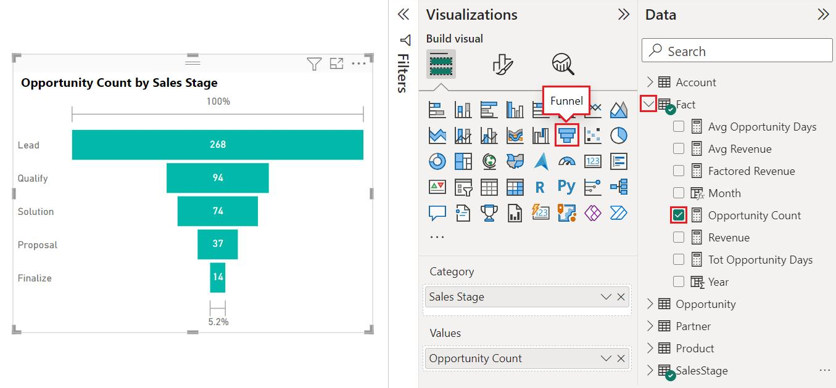
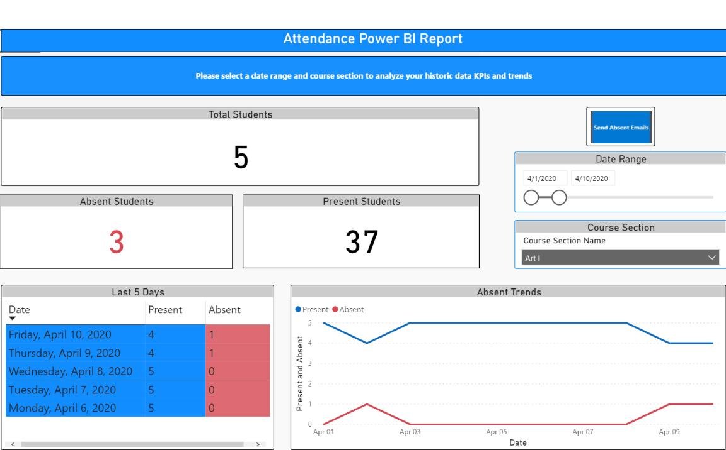
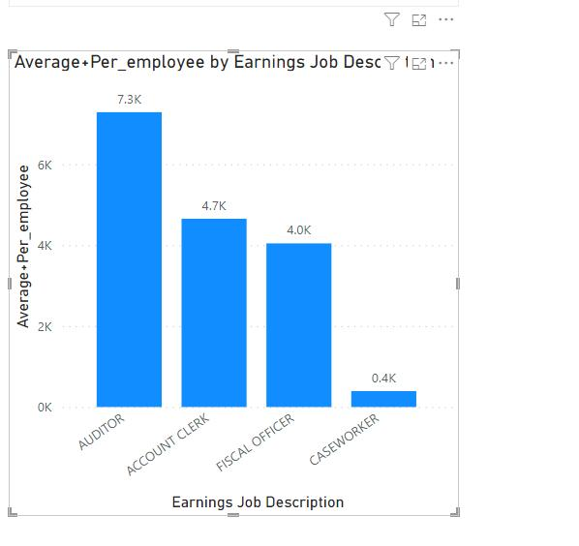

5. Dashboard Features Used
Dark Theme Dashboard
A dark blue theme was applied to improve dashboard appearance.
Theme Benefits
- Professional visual appearance
- Better readability
- Improved user experience

Interactive Charts
Interactive visualizations were implemented throughout the dashboard.
Features
- Dynamic filtering
- Cross-visual interaction
- Real-time analysis
Observation
- Users could analyze employee information more efficiently.
- Dashboard became more user-friendly and interactive.

Tools Used
- Microsoft Power BI
- Microsoft Excel
- Data Modeling
- Dashboard Design
- Data Visualization

Learning Outcome
On Day 23, I learned how to create and manage relationships between multiple datasets in Power BI.
I understood:
- how to build One-to-Many relationships
- how to create Many-to-One relationships
- how to implement Many-to-Many relationships
- how data modeling improves dashboard functionality
- how to design employee dashboards using multiple visualizations
- how KPI cards and charts help in organizational analysis
Conclusion
The Day 23 internship session provided practical experience in data modeling and dashboard development using Microsoft Power BI.
Relationships between Employee_Table and Employee_Details were successfully created using Model View. Different relationship types such as One-to-Many, Many-to-One, and Many-to-Many were implemented to connect employee information effectively. An interactive dashboard was developed using bar charts, KPI cards, area charts, pie charts, and funnel charts to analyze employee performance, department activities, project allocation, attendance, and salary distribution. This session enhanced my understanding of data relationships, dashboard design, and business intelligence reporting.

